Quels sont les plus connus sgbd

Mysql

Sql.server

Postgre.sql

-- DROP DATABASE IF EXISTS hebergement_social2204;

-- CREATE DATABASE herbergement_social2204;

-- USE hebergement_social2204; // SQL Server ou MySQL

CREATE TABLE jobs

(

job_id INT PRIMARY KEY,

job_name VARCHAR(50) NOT NULL

);

CREATE TABLE people

(

person_id INT,

person_lastname VARCHAR(255) NOT NULL,

person_firstname VARCHAR(50) NOT NULL,

person_birthdate DATE NOT NULL,

person_hiredate DATE NOT NULL,

person_active BOOL NOT NULL,

job_id INT,

PRIMARY KEY (person_id)

);

/*

DDL : Langage de définition des données relationnelles

CREATE DATABASE

CREATE TABLE

CREATE VIEW

CREATE PROCEDURE

CREATE TRIGGER

ALTER TABLE...

DROP TABLE ... (suppression)

*/

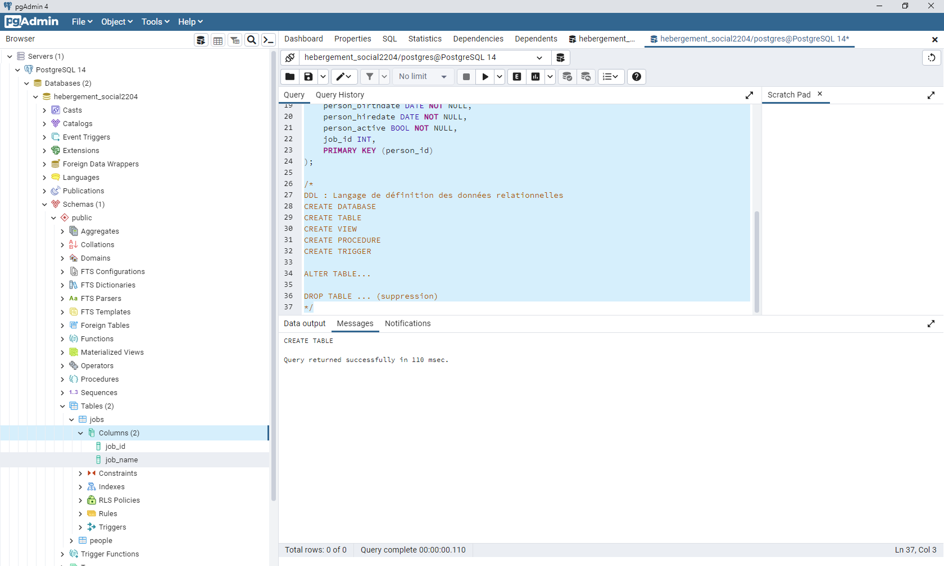

-- DROP DATABASE IF EXISTS hebergement_social2204;

-- CREATE DATABASE herbergement_social2204;

-- USE hebergement_social2204; // SQL Server ou MySQL

CREATE TABLE jobs

(

job_id INT PRIMARY KEY,

job_name VARCHAR(50) NOT NULL

);

CREATE TABLE people

(

person_id INT,

person_lastname VARCHAR(255) NOT NULL,

person_firstname VARCHAR(50) NOT NULL,

person_birthdate DATE NOT NULL,

person_hiredate DATE NOT NULL,

person_active BOOL NOT NULL,

job_id INT,

PRIMARY KEY (person_id)

);

INSERT INTO jobs

(job_id, job_name)

VALUES

(1, 'Concepteur'),

(2, 'Développeur'),

(3, 'Boulanger');

SELECT * FROM jobs;

INSERT INTO people

(person_id, person_lastname, person_firstname, person_birthday, person_hiredate, person_active)

/*

DDL : Langage de définition des données relationnelles

CREATE DATABASE

CREATE TABLE

CREATE VIEW

CREATE PROCEDURE

CREATE TRIGGER

ALTER TABLE...

DROP TABLE ... (suppression)

*/

--------------------------------------------------------------------------------------------------------------------------------------

INSERT INTO people

(person_id, person_lastname, person_firstname, person_birthdate, person_hiredate, person_active)

VALUES

(1, 'Brown', 'James', '1933-05-03', '1953-05-03', '0'),

(2, 'Jackson', 'Mickael', '1958-08-29', '1968-08-29', '0'),

(3, 'Presley', 'Elvis', '1935-01-08', '1955-01-08', '0'),

(4, 'Jagger', 'Mick', '1943-07-26', '1963-07-26', '1');

SELECT * FROM people;

SELECT person_lastname, person_firstname FROM people;

DROP TABLE IF EXISTS jobs;

CREATE TABLE roles

(

role_id INT PRIMARY KEY

role_name VARCHAR(50) NOT NULL

)

CREATE TABLE people

(

person_id INT,

person_lastname VARCHAR(255) NOT NULL,

person_firstname VARCHAR(50) NOT NULL,

person_birthdate DATE NOT NULL,

person_hiredate DATE NOT NULL,

person_active BOOL NOT NULL,

role_id INT,

PRIMARY KEY (person_id)

);

INSERT INTO roles

(role_id, role_name)

VALUES

(1, 'Concepteur'),

(2, 'Développeur'),

(3, 'Boulanger');

INSERT INTO people

(person_id, person_lastname, person_firstname, person_birthdate, person_hiredate, person_active)

VALUES

(1, 'Brown', 'James', '1933-05-03', '1953-05-03', '0'),

(2, 'Jackson', 'Mickael', '1958-08-29', '1968-08-29', '0'),

(3, 'Presley', 'Elvis', '1935-01-08', '1955-01-08', '0'),

(4, 'Jagger', 'Mick', '1943-07-26', '1963-07-26', '1');

SELECT * FROM people;

SELECT person_lastname, person_firstname FROM people;

SELECT * FROM jobs